Sparkling wines:
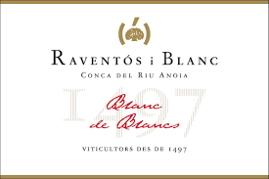
Raventos I Blanc Conca del Riu Anoia Cava Brut Blanc de Blancs
Grape Varietals: Macabeu, Xarel·lo and Parellada.
Style: Cava Brut Sparkling
Location: Penedes, Spain
Blanc de Blancs is a sparkling wine marked by the typicity of its place of origin, the Vinya del Llac, a vineyard over 40 years old, which allows the winemaker to obtain a structured, fresh and complex dry sparkling wine.

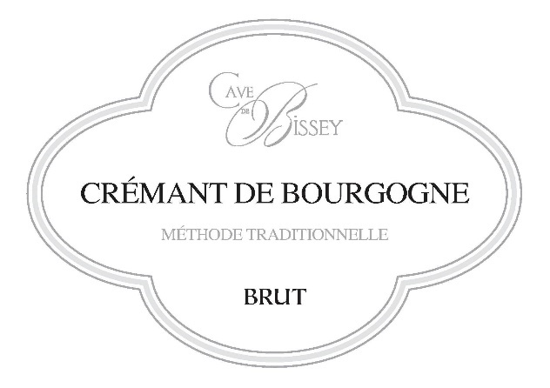
Cave de Bissey Cremant de Bourgogne Methode Traditionelle Brut Blanc
Grape Varietals: Chardonnay, Aligote & Pinot Noir
Style: Cremant de Bourgogne
Location: Burgundy, France
Cave de Bissey is a group of growers established since 1928 in Bissey sous Cruchaud. In the heart of the Côte Chalonnaise between the Côte de Beaune and the Mâconnais. It is one of the oldest cooperatives in Southern Burgundy and is very well known locally for the quality of the wines. A small-scale operation with just 7 employees. They are the only growers in the area to control the whole vinification process of their Crémant, from harvesting to bottling, which ensures excellent quality. Classic, bright flavors and a hint of creaminess keeps the complexity through the crisp, refreshing finish. A stunning approach to Cremant de Bourgogne!

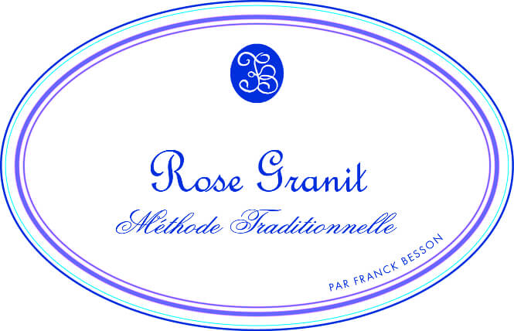
Franck Besson Rose Granit Methode Traditionelle Sparkling Rose
Grape Varietals: 100% Gamay
Style: Sparkling Rose
Location: Beaujolais, France
100% Gamay from vines over 40 years old with steep southern exposure in pink granite soils. 350 meters elevation. Hand harvested. Direct, whole cluster pressing of grapes, 6-12 hours skin contact with first fermentation in stainless steel tank for the ‘vin de base’. Traditional method vinification and aged 12 months on wooden “pupitre” at the estate. A Sparkling Gamay Rosé! Fun and delicious! Named the "Perfect Bubbly for Sunday Brunch" by the SPIRITED team! It's fresh and lively, leaning more towards a red wine sparkler than a typical Rosé - mingling sweet red cherries and minerals - deftly balancing sweet and sassy - finishing clean and dry. This is the first Sparkling Rosé "Beaujolais" we've ever offered. That said, this can't be labeled Beaujolais, as there is no A.O.C. designation for this sparkling catagory. BUT - since the grower'svineyards are in Julienas (and we're not!) we can say this is all Cru fruit! 40 Year old vines - farmed organically and hand harvested - from Julienas!

Rose wines:
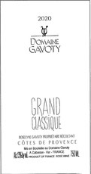
Domaine du Gavoty ‘Grand Classique’ Cotes de Provence Rose
Grapes varietals: Grenache, Cinsault, Carignan
Style: Dry Cotes de Provence Rose
Location: Provence, France
Gavoty’s “Grand Classique” combines Grenache and Cinsault in roughly equal proportions, with Carignan playing a minor role which varies based on the vintage’s character. Rather than being pressed immediately after harvest by rote as many Provence rosés are, “Grand Classique macerates for several hours before pressing, and the saignée and first-press juice are vinified separately. This allows Roselyn the flexibility to blend the more succulent and tender saignée with the more angular and architectural press juice in a manner to achieve the precise textural qualities she seeks in her wines. “Grand Classique” displays an uncanny equilibrium, with racy acidity wed to gleaming fruits that are just the right amount of vinous, all buttressed by an elegant, mouthwatering texture that speaks both to domaine’s healthy fruit and to Roselyn’s consummate blending skills. Combining a touch of saignée with the juice from the first pressing, striking a wonderful balance between vinosity and brisk drinkability. Both nose and palate are multilayered and beguiling, and although the fruit is brightly kinetic, there is a sense of regal richness to this cuvee.
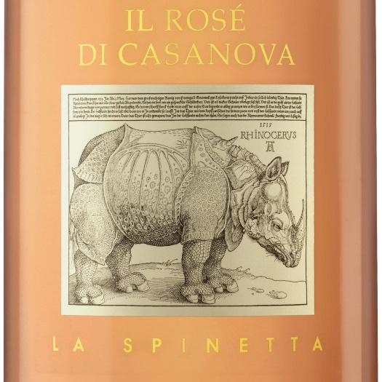
La Spinetta Il Rose di Casanova
Grapes varietals: Sangiovese, Prugnolo Gentile
Style: Dry Tuscan Rose
Location: Tuscany, Italy
From legendary Piedmontese & Tuscan winemaker Giorgio Ravetti!
Made half from Sangioveto and half Prugnolo Gentile (he is one of the few winemakers in Tuscany with access to both of these Sangiovese clones) grown exclusively to be harvested for the production of dry pink wine, these big reds are crushed together and then decanted off the skins after only an hour or so of skin contact. The resulting wine is more of shimmery copper hue than a full-on pink, and picks up the inherent peppery earthiness of Prugnolo and the tart cherry and pomegranate notes of its Sangioveto cousin. It’s a serious Rosato with impressive depth, beautiful acidity and even uncommon length. Bone dry, this begs for food and will challenge you to come up with dishes to make it sing even louder.

White wines:
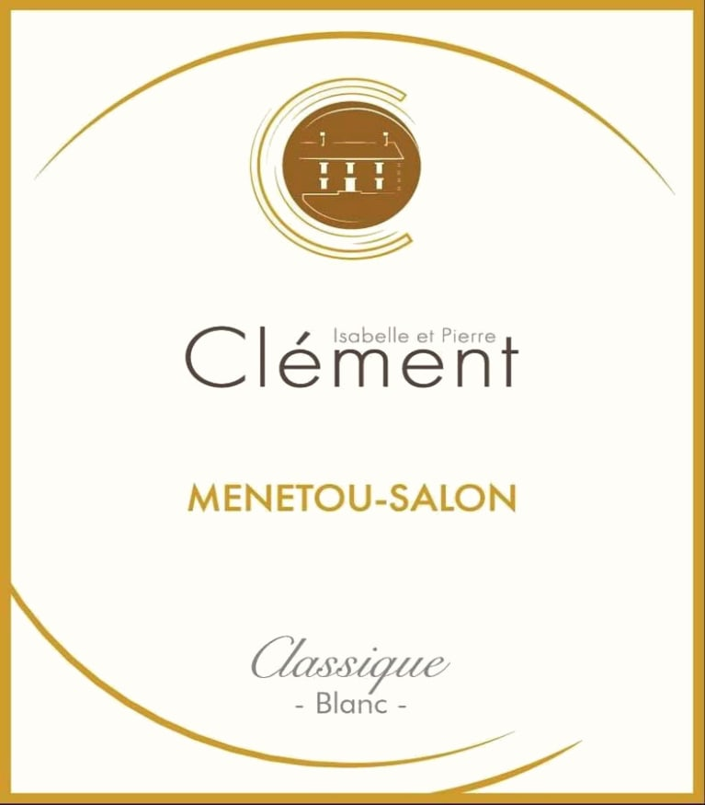
Isabelle et Pierre Clement Menetou-Salon ‘Classique’ Blanc
Grapes varietals: 100% Sauvignon Blanc
Style: Menetou-Salon Blanc
Location: Loire Valley, France
Any lover of Sancerre needs to be introduced to Menetou-Salon, which is as good as, and in many cases superior to most Sancerre. Beautiful, lively, Loire Valley Sauvignon Blanc, Absolutely stunning white from this ‘under-the-radar’ producer, Isabelle et Pierre Clement.This special Loire Valley terroir produces exotic, glorious fruit that results in powerful structure, delicious mid-palate fruit and an elegant, classically flinty, long & beautifully dry finish.This tiny family winery is a NEW FAVORITE of our SPIRITED Wine Tasting team. If you have not before enjoyed great Menetou-Salon, then now is the time!
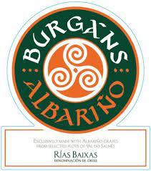

Burgan’s Albarino Rias Baixas White
Grapes varietals: 100% Albarino
Style: Albarino
Location: Rias Baixas, Spain
Truly outstanding Spanish Summer Water!!!
Spanish white wines are one of the most underrated (and best value)
wines in the world. The best of them rivals the great, more well-known whites of and the Loire Valley & Burgundy. Produced in the northwest corner of Spain’s illustrious Rias Baixas wine growing region, Alberino are renown for being refreshing, well balanced whites, with lovely texture and a clean, dry finish. They showcase beautiful aromas of white flowers, with flavors of tropical fruits and fine minerality. A world class style which is completely approachable and exceedingly delicious. Lovely acidity frames and balances the fruit, which make it an IDEAL dry, white wine to enjoy either as an amazing aperitif or with food!
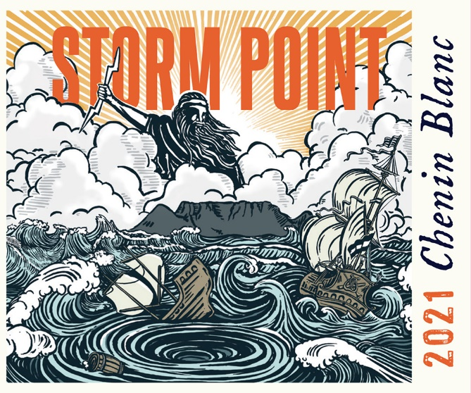
Storm Point Chenin Blanc
Grapes varietals: 100% Chenin Blanc
Style: Swartland Chenin Blanc
Location: Western Cape/Coastal Region, South Africa
This wine is freshly packed with nuance, playfulness and discovery. It has a well-defined and savory bouquet of lemon curd, white flowers, nectarine zest and a sprinkling of sea water. There is moderate viscosity and fine-lined acidity with a touch of lemon zest, peach skin, sea salt and elderflower on the palate. The bright finish is persistent and lingering. This is a serious value and showcases the sophistication of South Africa's beloved and most widely planted variety. Body, minerality & freshness… a classic expression of delicious southern hemisphere Chenin Blanc!
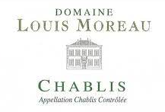
Louis Moreau Chablis AOC Blanc
Grapes varietals: 100% Chardonnay
Style: Chablis
Location: Burgundy, France
A fantastic expression of textbook Chablis – a wine all ‘foodies’ should have in heavy rotation on the dinner table. This Chablis displays a brilliant golden color, while its nose is floral with a hint of white (apple & pear). Expressing mineral & citrus notes, balanced by its roundness & fineness. Classic Chablis terroir shines thru this beauty. Chablis wine shows a nice gustatory presence with mineral and chalky hints and a perfect balance on the palate. Pairing wonderfully with fresh, summer seafood!
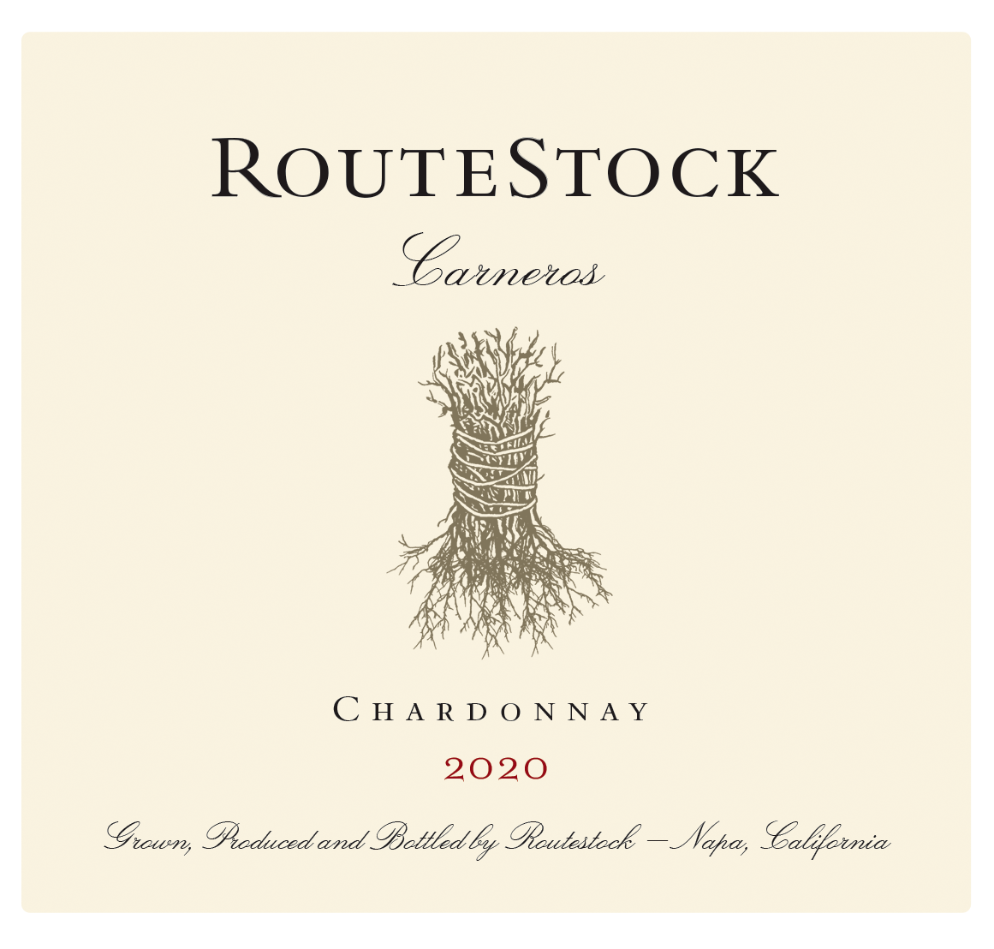
Routestock Carneros Chardonnay
Grapes varietals: 100% Chardonnay
Style: California Chardonnay
Location: Carneros AVA, California (Part in Sonoma County & Part in Napa Valley)
RouteStock is an invitation to discover the deep roots of winemaking in Napa and Sonoma, planted firmly at each step of your journey through our vineyard sites. Every glass tells the story of Napa and Sonoma’s remarkable fine wine heritage, from the famous routes that wind between the vineyards, to the roots that produce its world-renowned grapes. A quite complex wine that is not dominated by alcohol, oak or sugar, instead is integrated with all elements to bring great joy! The wine shows a beautiful seductive aroma of Meyer lemon, English thyme and ginger. The wine is vibrant and lively on the pallet, dancing between lemon, pear, custard and tarragon. There is a beautiful balance between the slight richness and inviting mouthfeel of the texture and the nice freshness of the finish.

Red wines:
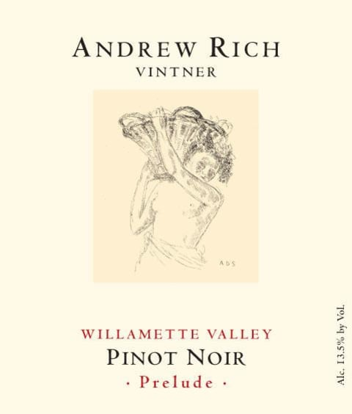
Andrew Rich ‘Prelude’ Pinot Noir Willamette Valley
Grapes varietals: 100% Pinot Noir
Style: Oregon Pinot Noir
Location: Willamette Valley, Oregon
From friend & local winemaker ANDREW RICH of Pittsfield! A true gentlemen and fantastic producer of
Willamette Valley Pinot Noir!! After one taste, this will be YOUR NEW SUMMER PINOT NOIR!
Pinot Noir has been the most versatile, enjoyable, and quite precise red wine for as long as we can remember! What better red wine to enjoy wherever you are this summer, than an elegant, perfectly balanced, and delicious Willamette Valley Pinot Noir! Irresistibly charming, dry yet smooth, with plenty of juicy, enticing, dark cherry and berry fruit. This beautiful wine is full of flirtatious hints that draw you right in… The lovely, mineral-accented Pinot Noir is silky, seamless and focused on the palate, offering a long, vibrant finish. A Truly Stunning Pinot Noir!
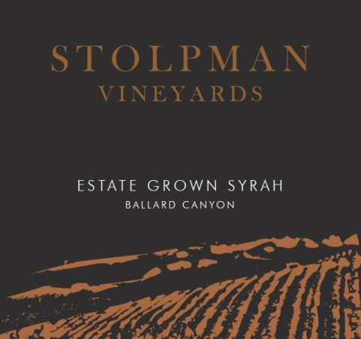
Stolpman Vineyards Estate Grown Syrah Ballard Canyon Santa Barbara County
Grapes varietals: 100% Syrah
Style: California Syrah
Location: Santa Barbara, Central Coast, California
Popping the cork, the nose screams of dark, brooding Syrah – a slam dunk in a blind tasting. The wine quickly opens up, dominated by delicate red fruits that pierce and crackle – bordering on peppermint, and ride high over a tantalizing fleshiness that has already completely enveloped tannins, even upon release. Balancing savory dried herbs round out this beautifully built Syrah masterpiece. On the finish, those same fresh red fruits still sing backed up by hints of smoke and char. The wine, although enjoyable in its infancy, will evolve into another benchmark vintage for Ballard Canyon Syrah!
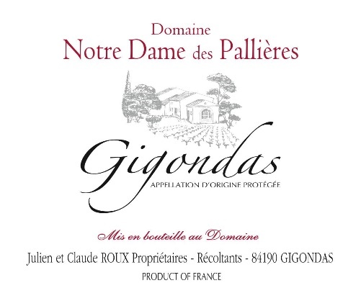
Notre Dame Des Pallieres Gigondas ‘Les Mourres’ Single Vineyard
Grapes varietals: Grenache, Syrah & Mourvedre
Style: Gigondas Rouge
Location: Gigondas, Rhone Valley, France
The Gigondas Les Mourres, a cuvee that has been terrific each of the past 5 vintages!! Notre Dame des Palloieres Gigondas ‘Les Mourres’ offers up a concentrated, yet an elegant and traditionally style bouquet of liquid raspberry, crushed rock, earth, and spices, this medium to full-bodied red has a solid mid-palate, sound underlying structure and at least a decade of longevity. This ‘smoking Gigondas’ stood out in our recent Southern French wine tastings and this estate needs to be on everyone’s radar! This wine does everything right in every vintage! Revealing a more medium ruby hue as well as classy notes of savory red and black fruits, dried flowers, ground pepper, garrigue, and spice box, this beauty hits the palate with medium to full-bodied richness, a layered, seamless mid-palate, and a great finish. It’s just loaded with Provençal charm, and I would be thrilled to drink bottles any time over the coming 10 years!!

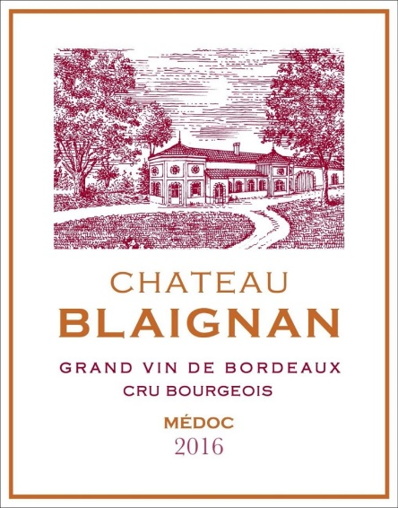
Chateau Blaignan Grand Vin Bordeaux Cru Bourgeois Medoc Rouge
Grapes varietals: Cabernet Sauvignon, Merlot,
Style: Medoc Rouge
Location: Medoc, Bordeaux, France
Ch. Blaignan is a tiny, impressive winery from the legendary wine growing appellation of Medoc. This glorious appellation is in many Bordeaux fan’s opinion, the pinnacle growing region on the Left Bank of Bordeaux for finesse, complexity, and affordability in great wines. No wine region has deeper wine making history than Bordeaux. Rich, deep, supple wines, which are some of the most sought-after wines in the world. The climate & terroir of these French Cabernet-dominated blends results in wines that are unique and undeniably ‘Bordeaux’! The clay soils of the region’s vineyards impart smoothness to these wines that results in subtle complexities and nuance that are nothing less that works of art. This is unquestionably one of the greatest Bordeaux values we’ve tasted over the past year... We were thrilled to find such finesse, power and elegance in a Medoc, especially at this price. Classic Bordeaux showing seductive aromatics, structure and layers of silky fruit we quickly committed to and purchased every case of this 2016 vintage that the winery had available! Rich and drinking beautifully already – showing flavors of cassis, black currants, ripe black cherries and a soft, silky, dry finish. An all-around, fantastic Bordeaux Value!!
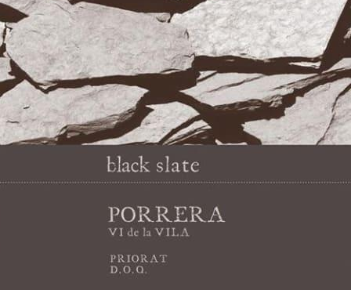
Black Slate Porrera Vi de La Vila Single Village Cru Priorat DOQ
Grapes varietals: Grenache, Carinena, Cabernet Sauvignon
Style: Priorat Red
Location: Priorat, Spain
To pioneers like Alvaro Palacios, the Priorat terroir had similarities to Burgundy and merited recognition as such. Thus, in 2009 Palacios and others introduced the Vi de la Villa wine designation program to give Priorat village cru designations similar to that used in Burgundy. The creation of the Vi de la Vila classification in Priorat motivated importer Eric Solomon and a group of winemakers in the region to craft a series of wines that reflected the unique terroir of individual villages in Priorat. The series, which is called Black Slate, was launched—–and today consists of four red wines and one white. The small quantity wines are hand-crafted by the individual winemakers and Eric Solomon, with the intent to have these high-quality wines available at prices. The lovely Porrera village release is an energetic, beautifully lifted and elegant Priorat that delivers plenty of jammy black raspberry, licorice, pepper, and underbrush like qualities that flow to a medium to full-bodied, fresh, and focused palate. Turning even more floral and elegant with air, this beautifully balanced and structured red has a core of acidity, layers of fruit, and no shortage of length on the finish. Absolutely delicious!

