S&P 500 Index – 30-Year Historical Chart [Slide 1]
Interactive chart of the S&P 500 stock market index since 1927. Historical data is inflation-adjusted using the headline CPI and each data point represents the month-end closing value. The current month is updated on an hourly basis with today's latest value. The current price of the S&P 500 as of June 08, 2020 is 3,232.39.
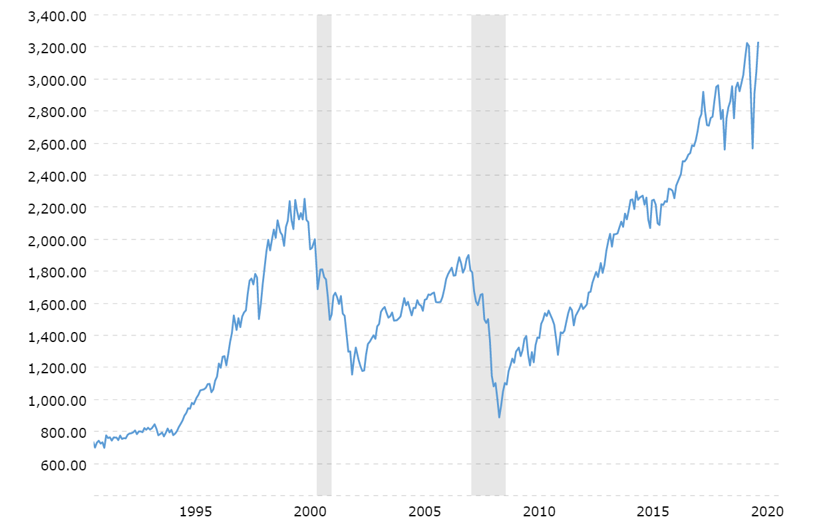
Source: MacroTrends (data available at https://www.macrotrends.net/2324/sp-500-historical-chart-data)

VIX Volatility Index - Historical Chart [Slide 2]
Interactive historical chart showing the daily level of the CBOE VIX Volatility Index back to 2005. The VIX index measures the expectation of stock market volatility over the next 30 days implied by S&P 500 index options. The current VIX index level as of June 8, 2020 is 25.81.

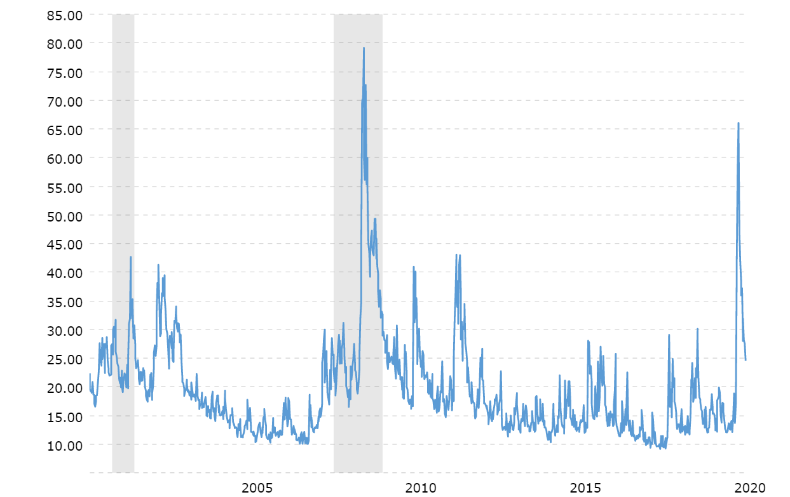
Source: MacroTrends (data available at https://www.macrotrends.net/2603/vix-volatility-index-historical-chart)
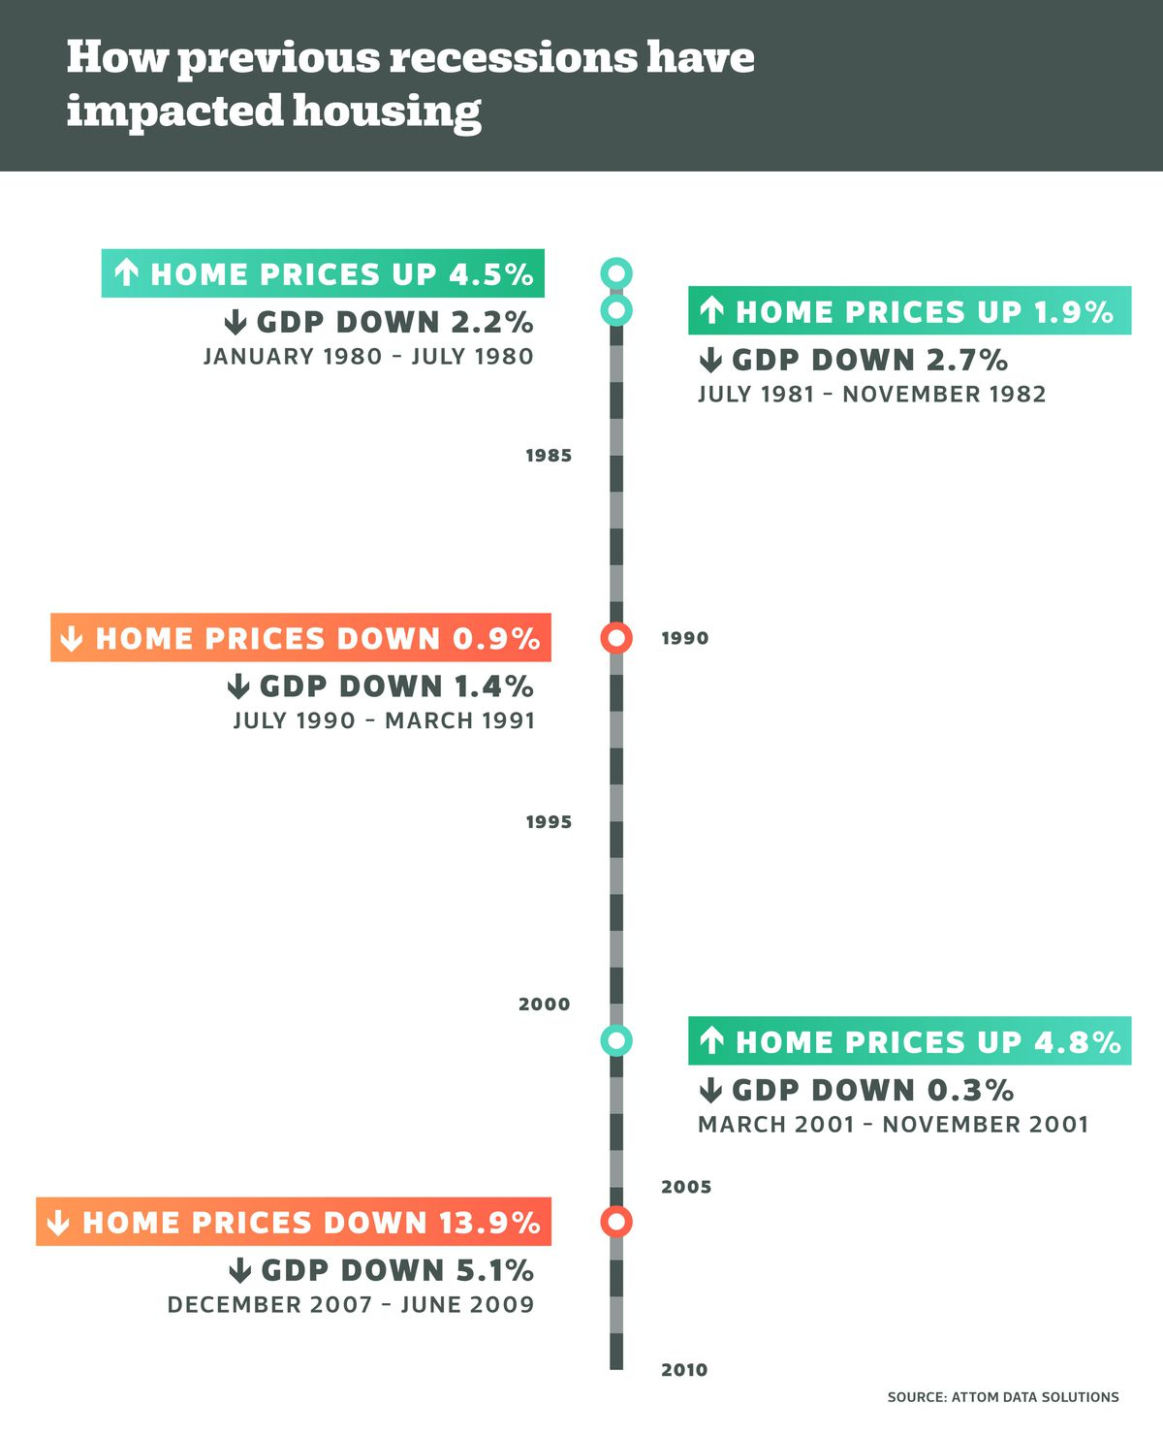

Dow Jones - 1929 Crash and 3-Year Bear Market [Slide 4]
This interactive chart shows detailed daily performance of the Dow Jones Industrial Average during the bear market of 1929-1932. Although it was the crash of 1929 that gained the most attention, stocks continued to fall for another three years until bottoming out in July of 1932.

(Log Scale)
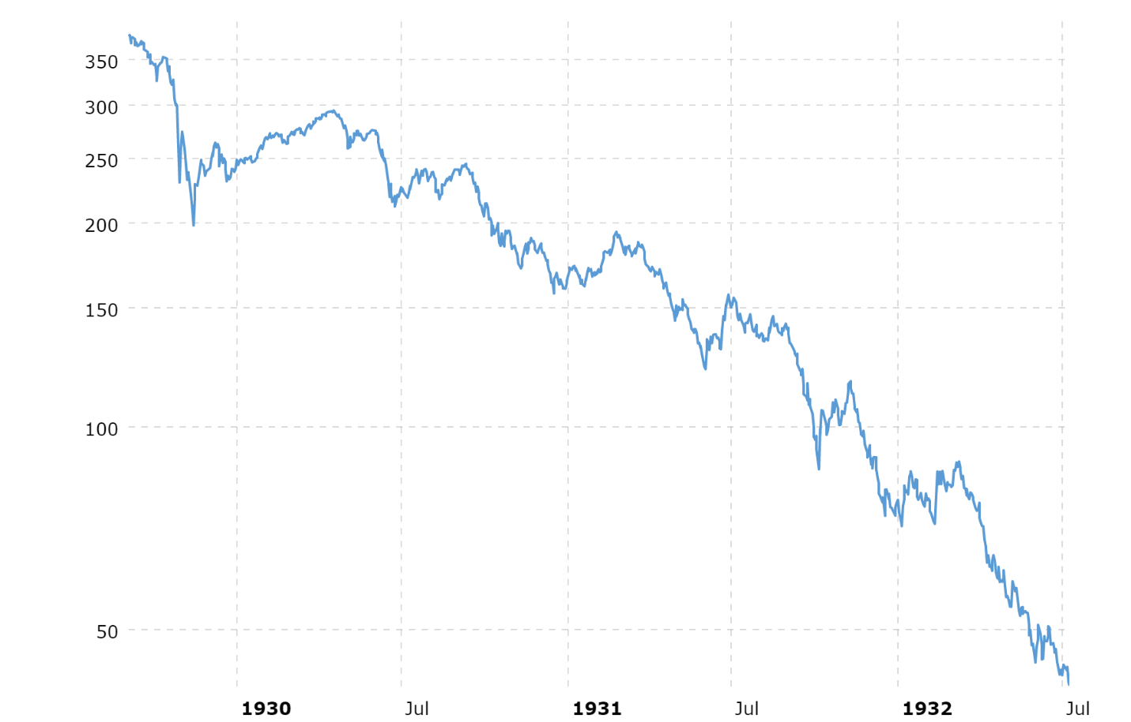

[Slide 5]

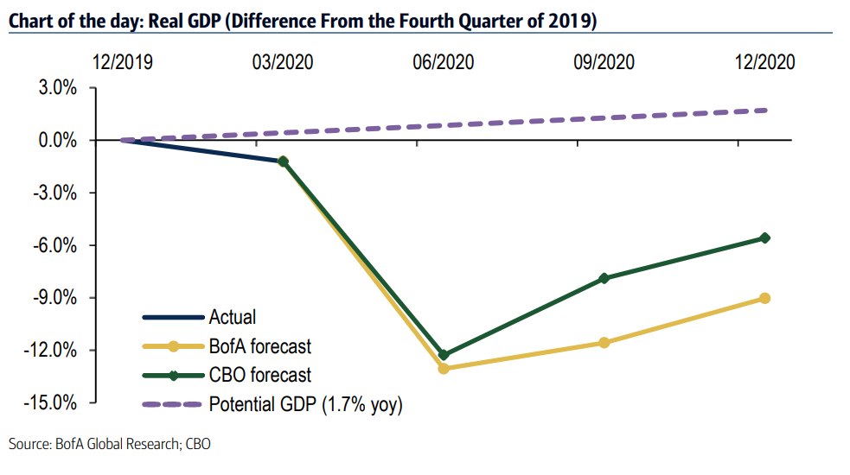

Daily Deaths Per Million People from Covid-19,
Seven-Day Moving Average [Slide 6]
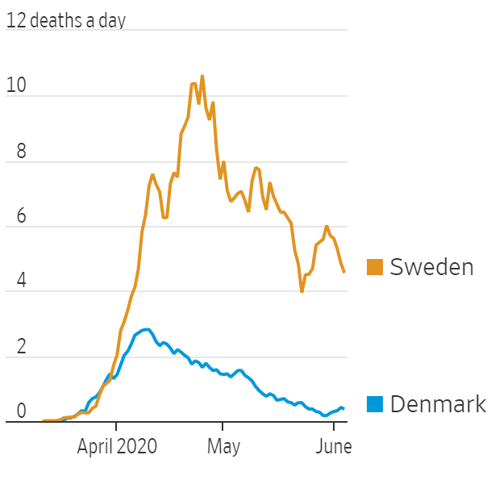

Sources: Wall Street Journal and Our World in Data

